***Task 1 : Create a GIT repository named as your enrollment number.***

***Create 2 folder in your repository named a Assignment_1 and Assignment_2.***

***Prepare a word file which contains each step of this task.***

***Upload your assignment in the respective folder. Share your repository link in google***

***form asked to you at the of submission***

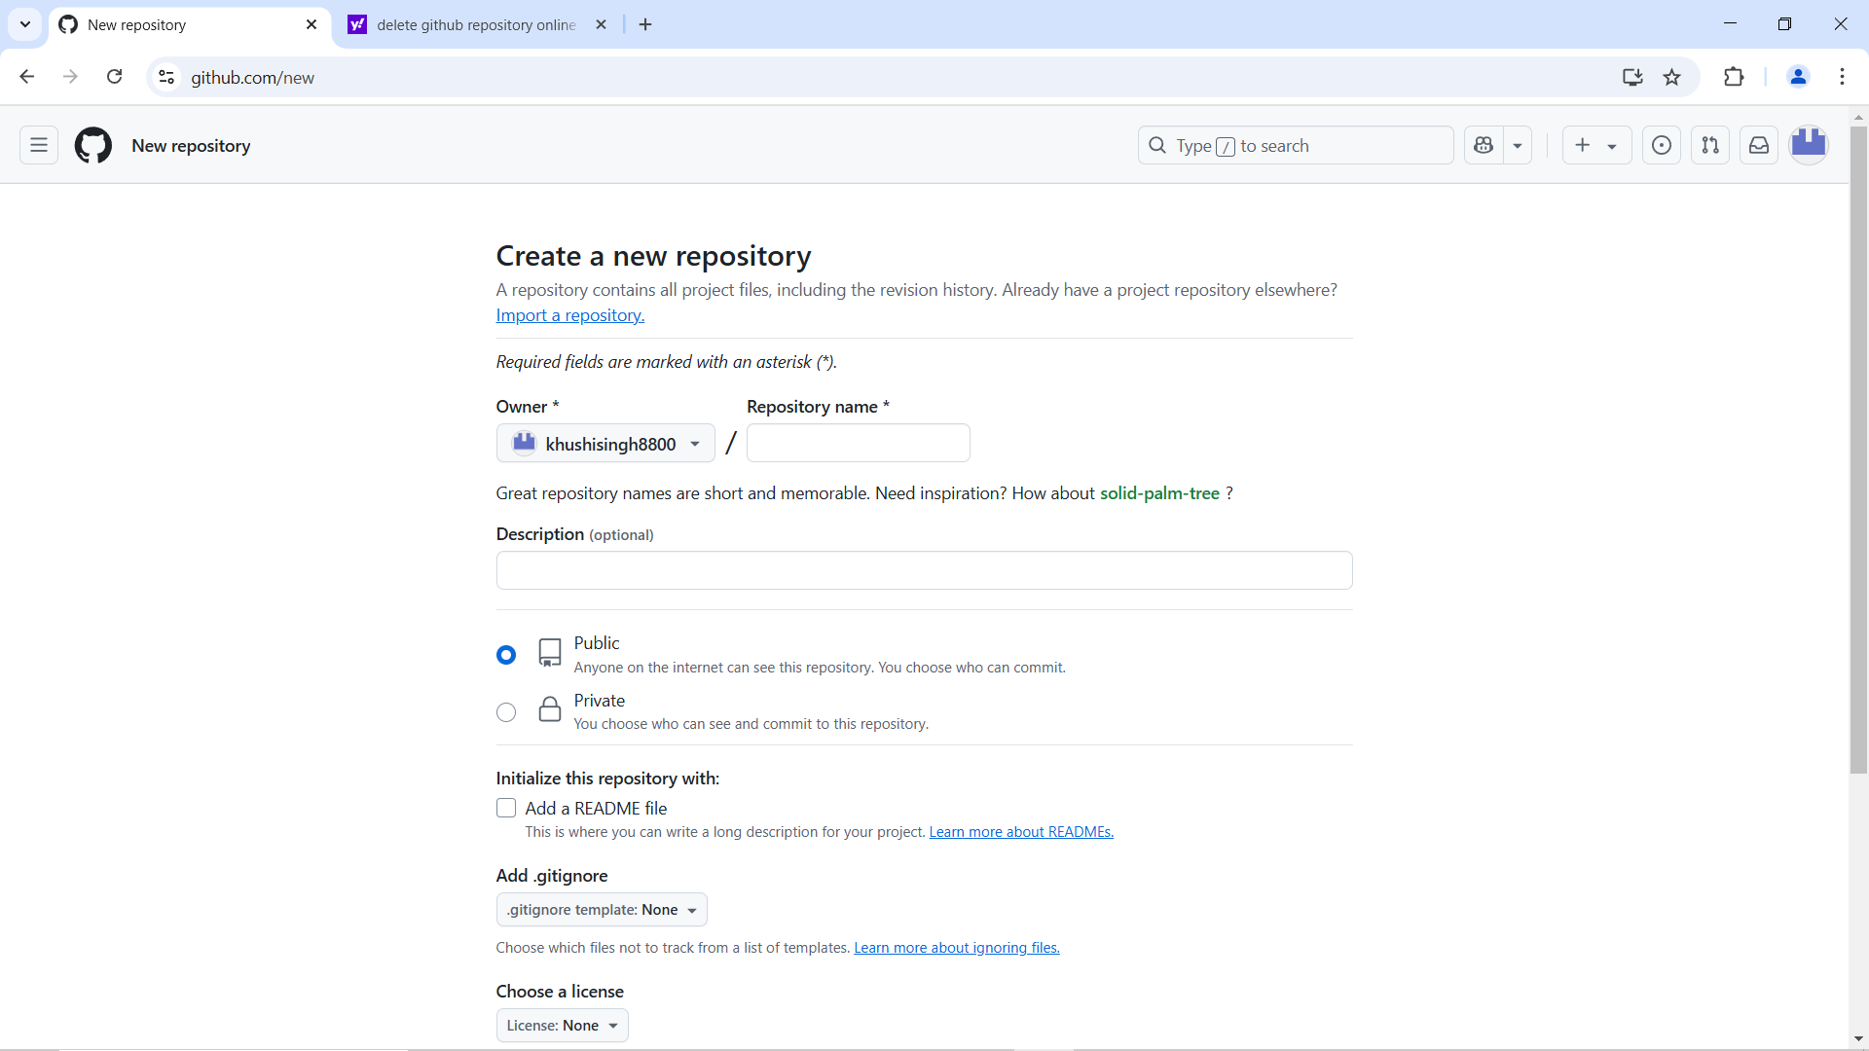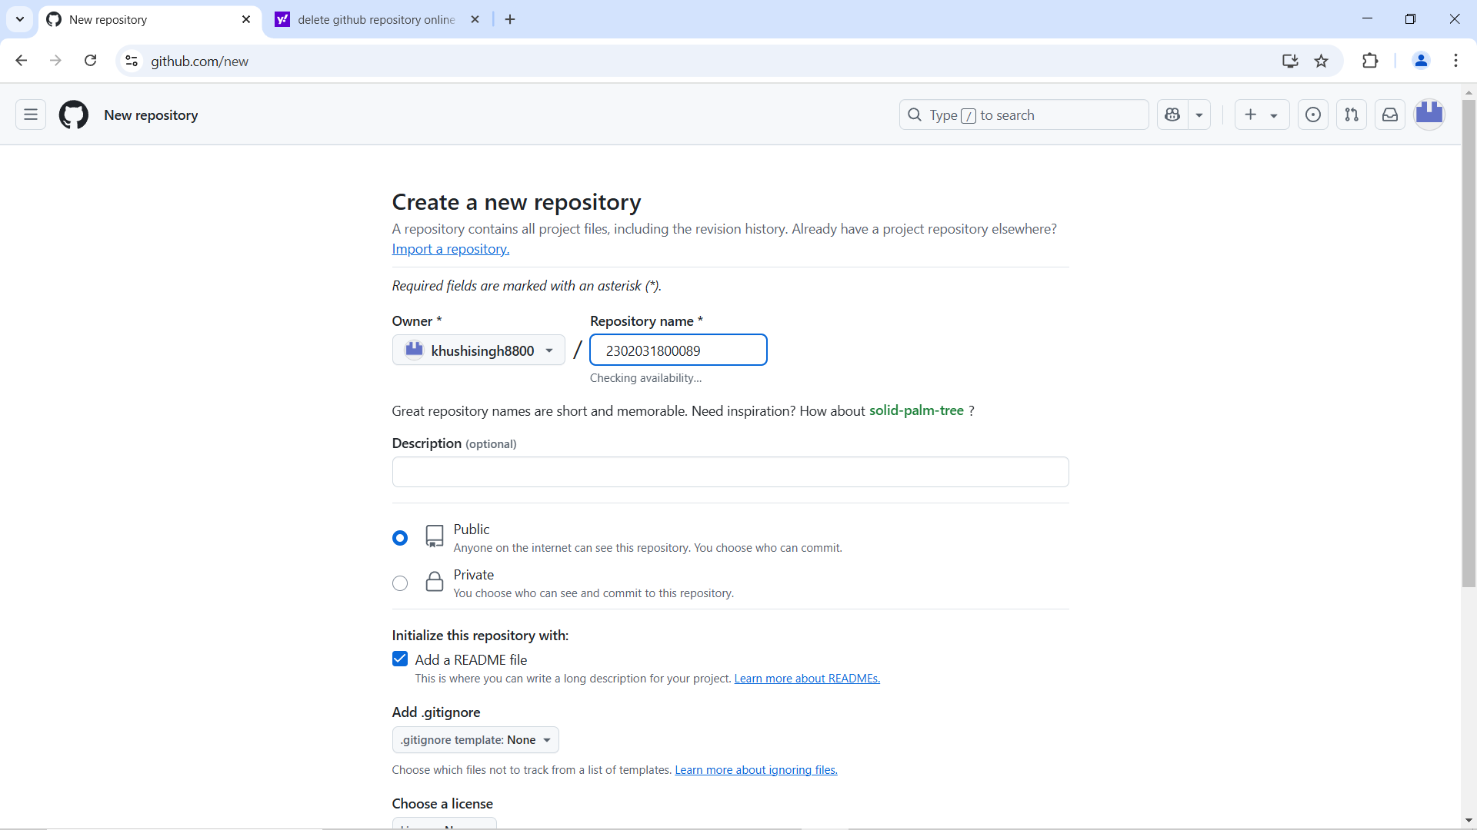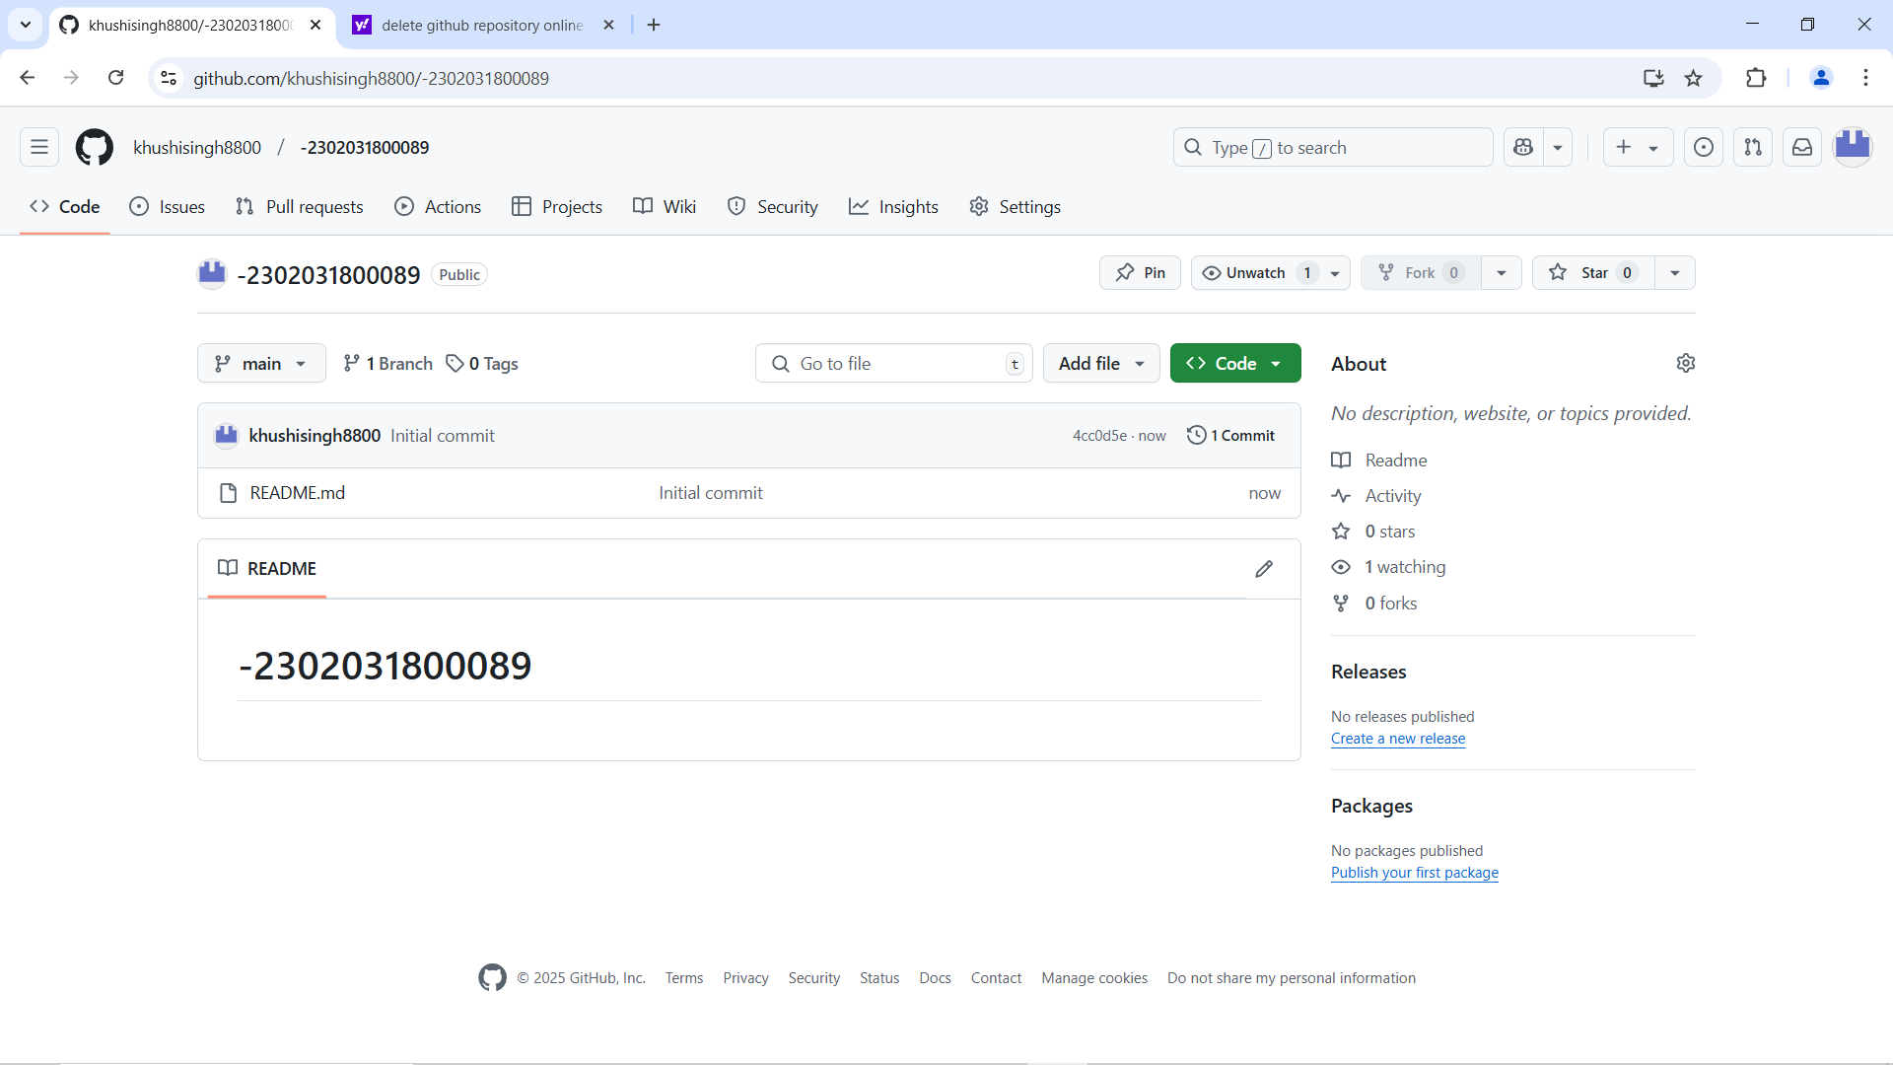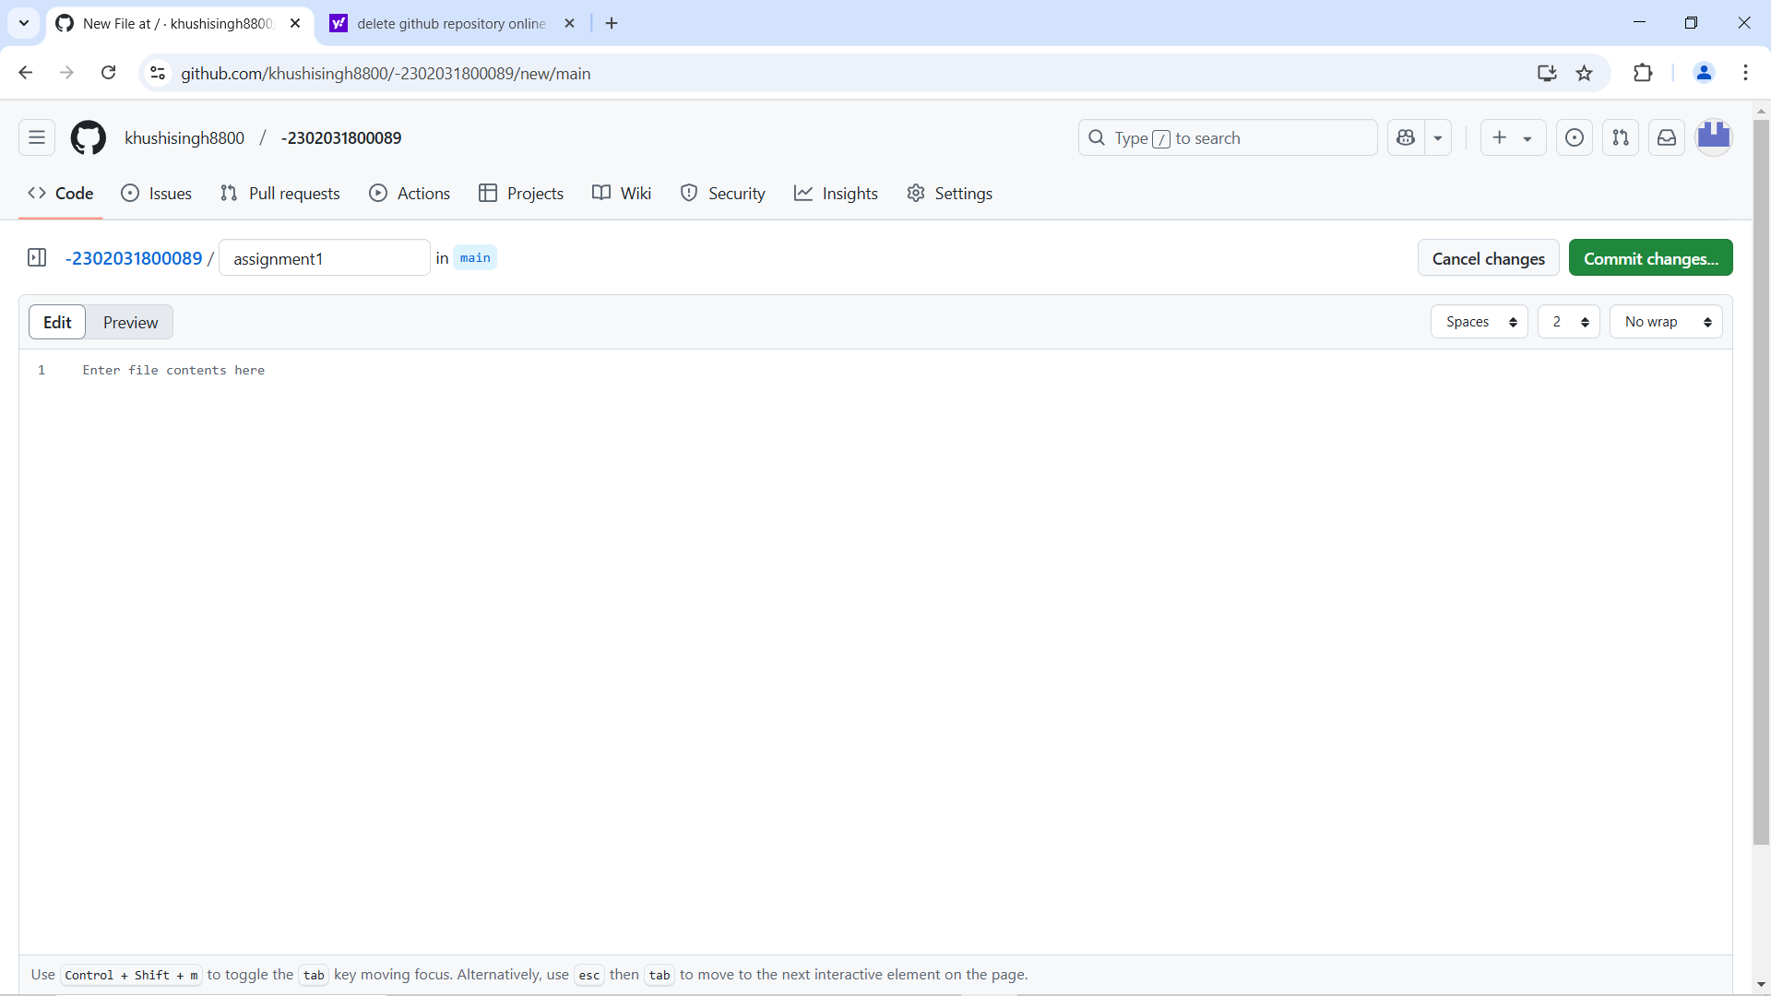

***Guided by-***

***Mr. Jaykumar Gandharva Prepared By-***

***Khushi singh***

***2302031800089 (4CSE_D_027)***